**SPH3U: 3.3 Newton’s Second Law of Motion**

1. **Newton’s second law**

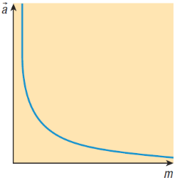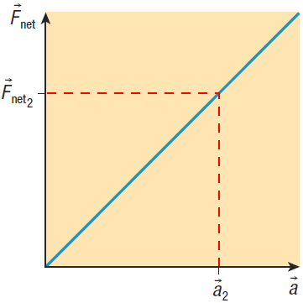

|  |  |
| --- | --- |
| Newton’s second law: |  |
| force vs. accel. |  |
| accel. vs. mass |  |

A net force of 36 N [forward] is applied to a volleyball of mass 0.25 kg. Determine the acceleration of the volleyball.

A 64 kg runner starts walking at 3.0 m/s [E] and begins to speed up for 6.0 s, reaching a final velocity of 12.0 m/s [E]. Calculate the net force acting on the runner.

A 9100 kg jet moving slowly on the ground fires its engines, resulting in a force of 22 000 N [E] on the jet. The force of friction on the jet is 3800 N [W].

1. Draw the FBD for the jet.
2. Calculate the net force acting on the jet.
3. Calculate the acceleration of the jet.
4. **Newton’s second law and gravity**

|  |  |
| --- | --- |
| Force due to gravity: |  |

In an investigation, students place a 0.80 kg cart on a table. They tie one end of a light string to the front of the cart, run the string over a pulley, and then tie the other end to a 0.20 kg hanging object. Assume that no friction acts on either object.

1. Determine the magnitude of the acceleration of the cart and the hanging object.
2. Calculate the magnitude of the tension.
3. **Summary**

**Homework:** page 136: #1-4, 6, 10-11